Static Routing

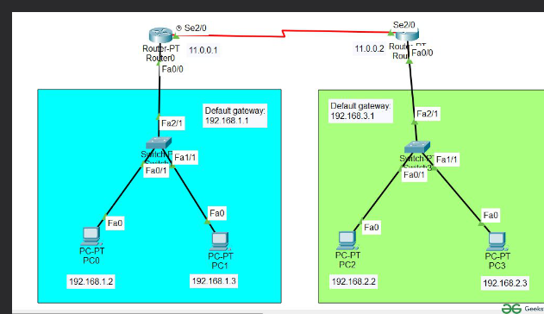

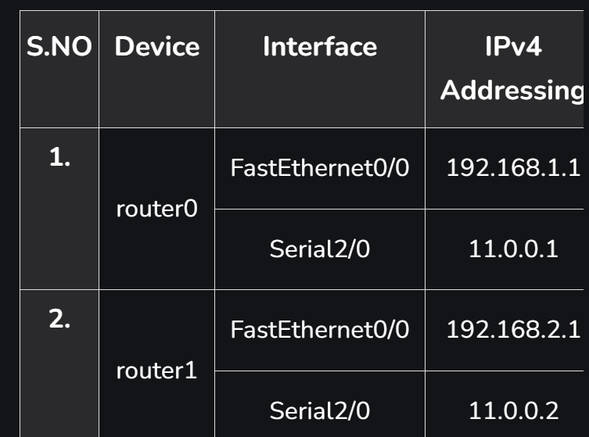

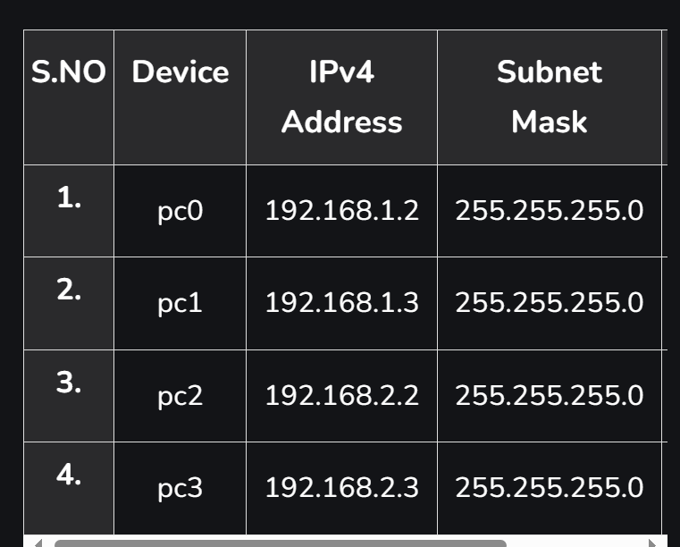

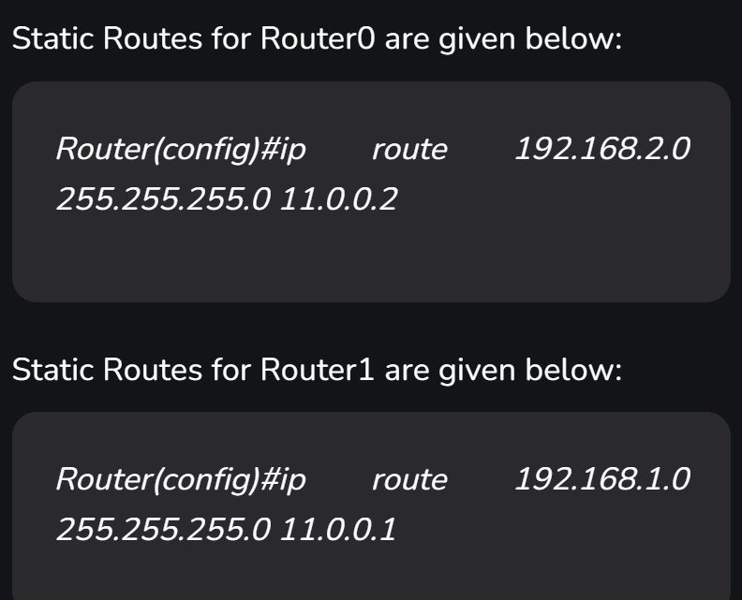

Hey Talha! Let's break down the differences between static and dynamic routing:

### Static Routing

- **Configuration:** Manually configured by a network administrator.

- **Usage:** Best for small, simple networks where routes don't change often.

- **Advantages:**

- Simple and straightforward to set up.

- No additional overhead for route discovery and maintenance.

- **Disadvantages:**

- Doesn't scale well for large or frequently changing networks.

- Requires manual updates for any network changes, which can be time-consuming and error-prone.

- **Example:**

```bash

Router(config)# ip route 192.168.2.0 255.255.255.0 192.168.1.2

```

### Dynamic Routing

- **Configuration:** Automatically managed by routing protocols.

- **Usage:** Ideal for larger, more complex networks where routes change frequently.

- **Advantages:**

- Automatically adapts to network changes, reducing the need for manual intervention.

- Can handle complex networks with multiple paths and redundancy.

- **Disadvantages:**

- Adds overhead to the network due to routing protocol communications.

- Requires more CPU and memory resources on routers.

- **Example Routing Protocols:**

- **RIP (Routing Information Protocol)**

```bash

Router(config)# router rip

Router(config-router)# network 192.168.1.0

```

- **OSPF (Open Shortest Path First)**

```bash

Router(config)# router ospf 1

Router(config-router)# network 192.168.1.0 0.0.0.255 area 0

```

- **EIGRP (Enhanced Interior Gateway Routing Protocol)**

```bash

Router(config)# router eigrp 100

Router(config-router)# network 192.168.1.0

```

### Summary

- **Static Routing:** Manual setup, best for small/stable networks.

- **Dynamic Routing:** Automatic adjustments via protocols, ideal for larger/changing networks.